**"NIE HowZatt!"**

A PROJECT REPORT SUBMITTED TO

**THE NATIONAL INSTITUTE OF ENGINEERING, MYSURU**

(An Autonomous College)



In partial fulfillment of the requirements for Project work (Database Laboratory), Fifth semester

**Bachelor of Engineering**

**in**

**Computer Science and Engineering**

*Submitted by*

**OJASWI ATHGHARA (4NI17CS049)**

**NIKHIL KUMAR (4NI17CS047)**

**PRIYESH SHEKHAR JHA (4NI17CS059)**

Under the Guidance of

MR. YOGESH M J  
ASSISTANT PROFESSOR

R S SINDHU DEVAKI

ASSISTANT PROFESSOR

**DEPARTMENT OF COMPUTER SCIENCE AND ENGINEERING**

**THE NATIONAL INSTITUTE OF ENGINEERING**

Mysore-570 008

2019-2020

**DEPARTMENT OF COMPUTER SCIENCE AND ENGINEERING**

**THE NATIONAL INSTITUTE OF ENGINEERING**



***CERTIFICATE***

This is to certify that the project work entitled “**NIE HowZatt!**” is a work carried out by **Ojaswi Athghara (4NI17CS049), Nikhil Kumar (4NI17CS047) and Priyesh Shekhar Jha (4NI17CS049)** in partial fulfillment for the project work (Database Laboratory), fifth semester, Computer Science & Engineering, The National Institute of Engineering **(**Autonomous Institution under Visvesvaraya Technological University, Belagavi) during the academic year 2019-2020. It is certified that all corrections and suggestions indicated for the Internal Assessment have been incorporated in the report deposited in the department library. The project work report has been approved in partial fulfillment as per academic regulations of The National Institute of Engineering, Mysuru.

**Internal Guides** **Professor & Head**

**______________ _______________ _______________**

R. S. Sindhu Devaki Assistant Professor Dept. of CS&E NIE, Mysuru

Mr. Yogesh M.J.  
Assistant Professor Dept. of CS&E NIE, Mysuru

Dr. V K Annapurna  
Professor and Head  
Dept. of CS&E  
NIE, Mysuru

**Examiners**

_________________

Name:  
Designation:

_________________

Name:  
Designation:

**ACKNOWLEDGEMENTS**

We would like to express our sincere gratitude to all those who helped us in completing the project successfully. We express our profound thanks to Dr. G Ravi, Principal, NIE, Mysore for much moral support and encouragement.

We are grateful to Dr. V K Annapurna, Prof. and Head of the department of Computer Science and Engineering, NIE for support and encouragement in facilitating the progress of this work.

The satisfaction that accompanies the successful completion of any task would be incomplete without the mention of people whose ceaseless cooperation made it possible, whose constant guidance and encouragement crown all efforts with success.

We are grateful to our project guides, Mr. Yogesh M J and Miss R. S. Sindhu Devaki for the guidance, inspiration and constructive suggestions which were very helpful to us in the preparation of this project.

We also thank our colleagues who have helped in successful completion of the project. Finally, we thank our families and friends for being a constant source of inspiration and advice.

-OJASWI ATHGHARA

-NIKHIL KUMAR

-PRIYESH SHEKHAR JHA

**ABSTRACT**

This “NIE HOWZATT!!” is a cricket statistics management application aimed to display stats of the cricket tournaments like teams, players, results of match and player performance at one place which will increase transparency in all aspects of the game.

The Project includes features such as:

* **Schedule of Tournament:** Match dates and team names
* **Team Details:** Names of all teams with their captain names and points
* **Points Table:** A detailed description of points scored by all teams
* **Player Statistics:** Individual player statistics of each team
* **Match Summary:** A brief summary of last match played with results.
* **Dashboard:** A full featured Dashboard for administrator

The project uses latest technologies such as HTML5, CSS3, Bootstrap 4, JavaScript, Python, Flask and MySQL.

The scope of this project is currently limited to the HPL tournament in NIE MEN’S Hostel but with a few minor changes and upgrades can applied to scale the project for Inter Branch Tournaments in NIE College.

**Table of Contents**

**1. Introduction………………………………………………………………………………………………7**

**2. System Analysis…………………………………………………………………………………………8**

**2.1 Existing System**

**2.2 Proposed System**

**2.3 System Requirements**

**2.3.1 Hardware Requirements**

**2.3.2 Software Requirements**

**3. System Design………………………………………………............................................10**

**3.1 ER Diagram**

**3.1.1 ER Diagram Explanation**

**4. System Implementations…………………………………….......................................14**

**4.1 User Side Implementation**

**4.2 Administrator Side Implementation**

**5. System Testing………………………………………………………………………………………….17**

**5.1 Introduction**

**5.2 Unit Testing**

**6. Results…………………………………………………………………………………………………….18**

**7. Conclusion and Future Enhancement…………………………………………………….…25**

**8. References…………………………………………………………………………………………….…26**

**List of Figures**

|  |  |
| --- | --- |
| **Figure No.** | **Description** |
| 3.1 | Table Information |
| 6.1 | Home Page |
| 6.2 | Schedule table |
| 6.3 | Points table |
| 6.4 | Login Page |
| 6.5 | Admin Dashboard 1 |
| 6.6 | Admin Dashboard 2 |
| 6.7 | Match Summary Insert |
| 6.8 | Player Statistics Update |
| 6.9 | Last Match Details |
| 6.10 | Team Table |
| 6.11 | Player Table |
| 6.12 | About page and credits |

**Chapter 1**

**Introduction**

Cricket has become one of the world class famous and popular games. It is the game of bat and ball which includes eleven players. Most of analysis is being conducted to measure the performance of the teams and individual players from all perspectives. The HPL managing committee of NIE Men’s Hostel host a number of matches during the HPL tournament. It becomes very difficult to manage and update players’ and matches’ data. The current system uses pen and paper records to manage the data. In the current system (paper based) it is very difficult to record runs, wins, loses, etc. and to find the same details regarding the tournament. The transparency is also compromised and players are not able to see their statistics in real-time.

The online statistics management system we are proposing is “NIE HowZatt!”. It manages the overall statistics of NIE HPL. It contains all the information about each player related to their batting and bowling statistics. It provides overall batting and bowling statistics of each team participating in HPL. It provides separate information about each team such as their ranks, and past records. It gives information about each player such as their teams.

NIE HowZatt! is very effective because it adds new players statistics and new team statistics every time, so that record will be updated with the statistics and new players in the game. The administrator can add new players with all their statistics. Only administrator will have the access to modify the statistics. All the users can see the statistics they want just by clicking on the specified field.

NIE HowZatt! is a web application designed for all kinds of operating systems capable of running in a web browser. This software is easy to use for all kinds of people with little or no knowledge of computer operations. It features a familiar and well thought-out, an attractive user interface, combined with strong searching and insertion capabilities.

This whole website provides user friendly experience and for implementing that we used HTML5, CSS3, JavaScript, Bootstrap at the front end and Python, Python Flask, MySQL at the back end for server and database.

**Chapter 2**

**System Analysis**

**EXISTING SYSTEM**

Currently the existing systems are not efficient in providing the statistics of cricket to the people interested in the game. Some people take this as an interesting sport and want to be updated with all the current information about cricket of all the players and teams currently playing international cricket. Some people just want to be updated for general knowledge.

The HPL managing committee of NIE Men’s Hostel host a number of matches during the HPL tournament. It becomes very difficult to manage and update players’ and matches’ data. The current system uses pen and paper records to manage the data. In the current system (paper based) it is very difficult to record runs, wins, loses, etc. and to find the same details regarding the tournament. The transparency is also compromised and players are not able to see their statistics in real-time.

**PROPOSED SYSTEM**

The system that we are proposing is far much better and advanced the current existing ones. This site is created with the help of advanced technology and is backed by a powerful and effective database. The statistics on this site are updated on regular basis so that no false information will be spread among cricket enthusiasts and people related to cricket. The interface of this site is so simple that anyone can use it even the one with no or very less knowledge about computers. Only they have to click on the correct button and they will get their required updated statistics about any particular player, team, number of players in a particular team, information about all the players of a particular team and much more information related to Hostel Premier League.

To avoid any misleading information, the statistics are updated on a regular basis. Only the authorized person can do changes and add new entries, no other external person has the reach to alter the data.

**SYSTEM REQUIREMENT**

A software requirements definition is an abstract description of the services, which the system should provide, and the constraints under which the system must operate. It should only specify the external behavior of the system and not concerned with system design characteristics. It is a solution, in a natural language plus diagram of what services the system is expected to provide and the constraints under which it has to operate.

#### Hardware requirements

1. Processor: IntelPentium4
2. RAM :512MB
3. Hard Disk Drive :3GB
4. Key Board: Standard 101/102 key keyboard
5. Monitor: Display Panel (1024 x764)
6. Network Adapter: SMC Ethernet Card Elite 16Ultra
7. Mouse: Logitech Serial Mouse

#### Software requirements

1. Operating System: Windows 7 and above/UBUNTU 16.04 or above
2. Front- End: HTML5, CSS3, JavaScript, Bootstrap
3. Connecting Front and back-end: FLASK
4. Back- End Server: Python Flask
5. Database: MySQL

**Chapter 3**

**System Design**

As Discussed above the website is made using flask. MySQL is used as the database manager. The front-end is made using HTML, CSS and JavaScript. The details of these libraries and languages in given below:

**MySQL**

MySQL is an Oracle-backed open source relational database management system (RDBMS) based on Structured Query Language (SQL). MySQL runs on virtually all platforms, including Linux, UNIX and Windows. Although it can be used in a wide range of applications, MySQL is most often associated with web applications and online publishing.

MySQL is ACID-compliant and implements most of the SQL standard, using a dynamic and weakly typed SQL syntax that does not guarantee the domain integrity.

MySQL is a popular choice as embedded database software for local/client storage in application software such as web browsers. It’s is arguably the most widely deployed database engine, as it is arguably the most widely deployed database engine, as it is used today by several widespread browsers, operating system, and embedded systems (such as mobile phone), among others. My SQL has bindings to many programming languages.

**HTML**

HTML or HYPERTEXT MARKUP LANGUAGE is the standard markup language used to create webpage. The purpose of the web browser is to read HTML documents and compose them into visible or audible web pages. The browser does not display the HTML tags, but uses the tags to interpret the content of the page. HTML describes the structure of a website semantically along with cues for presentation, mailing it a markup language rather than a programming language.

Web browsers can also refer to cascading style sheets (CSS) to define the look and layout of text and other material. The W3C maintainer of both the HTML and the CSS standards, encourages the use of CSS over explicit presentational HTML.

**Cascading Style Sheets**

Cascading style sheets (CSS) is a style sheet language used for describing the presentation of a document written in a markup language. Although most often used to set the visual style of web pages and user interface written in HTML and XHTML, the language can be applied to any XML document, including plain XML, SVG and XUL, and is applicable to reading in speech or on other media. Along with HTML and JavaScript, CSS is a cornerstone technology used by most websites to create visually engaging web pages, user interface for web applications, and user interface for many mobile applications.

CSS is designed primarily to the separation of document content from document presentation ,including aspects such as the layout, colors and fonts .This separation can improve content accessibility ,provide more flexibility and control in the specification of presentation characteristics ,enable multiple HTML pages to share formatting by specifying the relevant CSS in a separate .css file , and reduce complexity and repetition in the structural content.

**Materialize**

Created and designed by Google, Material Design is a design language that combines the classic principles of successful design along with innovation and technology. Google's goal is to develop a system of design that allows for a unified user experience across all their products on any platform. We are using their CSS and JS extensions for our website.

The structure of the tables used are in the following figures:

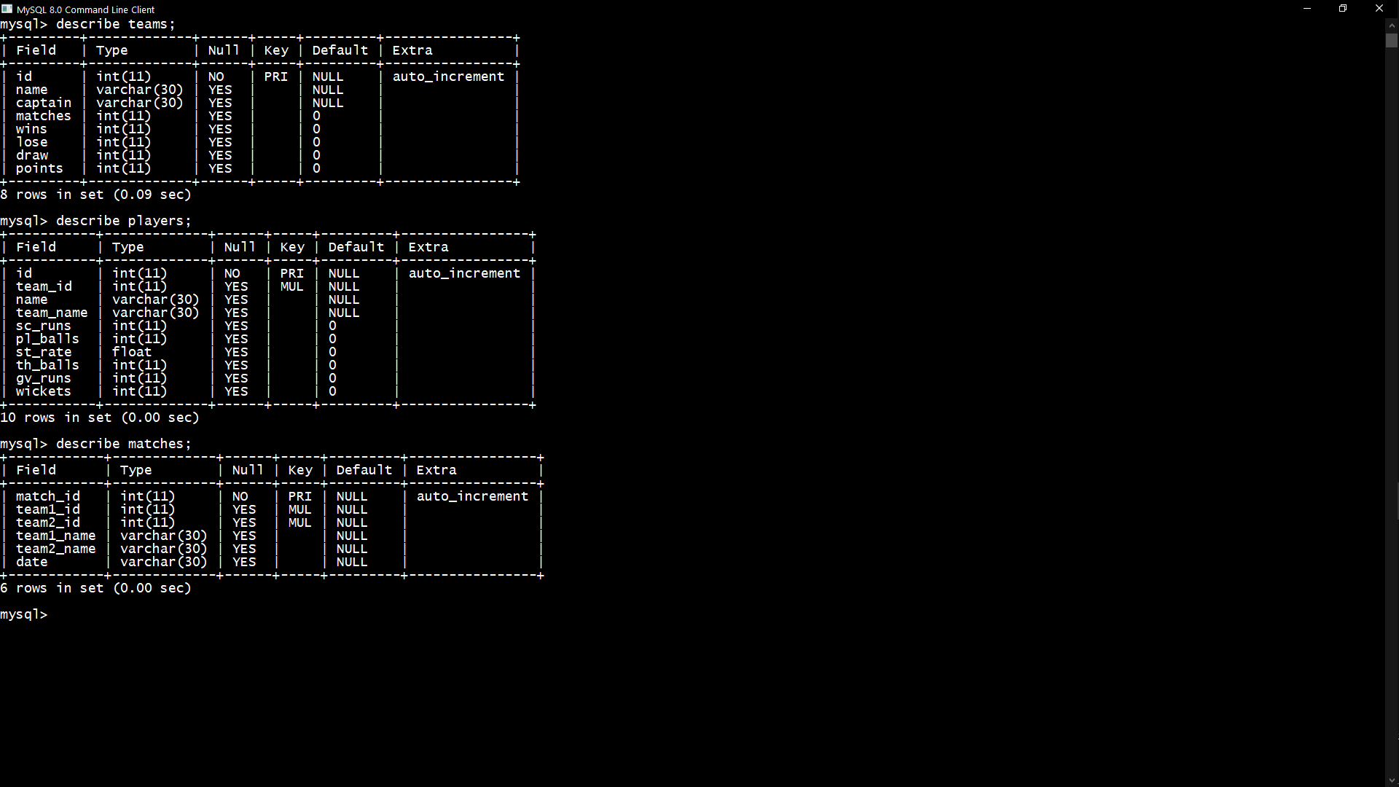

Fig 3.1 – Table Information

Various other functionalities are also provided in the data base like triggers, views, procedures, joins and indexes.

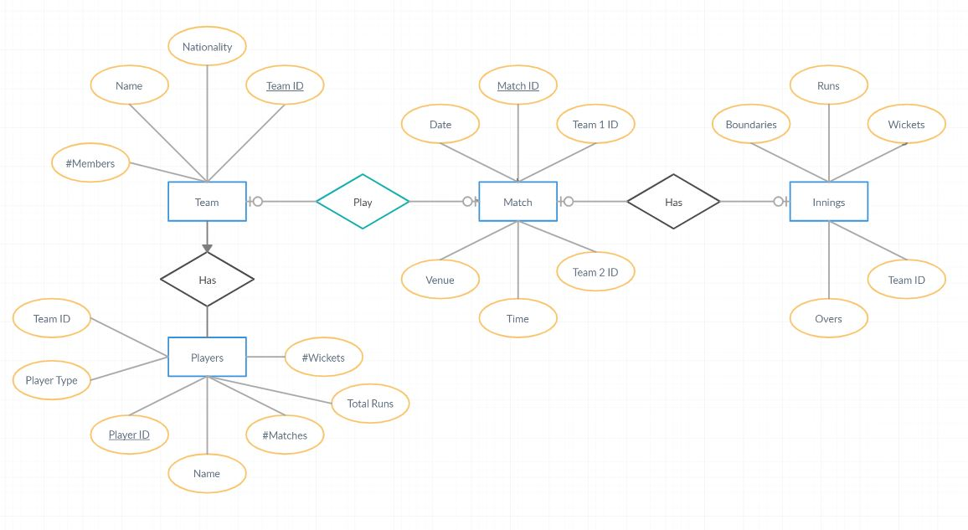**ER Diagram**

**Chapter 4**

**System Implementation**

The system proposed is implemented in as simple and user friendly as possible so that anyone can use it without facing any problem.

**USER SIDE IMPLEMENTATION:**

Anyone who wants to use the site can go on it directly and use it. Whatever information they want they just have to click on that option .On the top of the web page there will be menu bar that contains buttons that provide all the functionalities .On clicking on those button take on another web page where the data which will be fetched from the database will be shown in the form of proper format .

The user either can go back to the home page for taking more information by using the button functionalities provided or they can directly go to other web page because the buttons are provided on every web page of the web site.

For creating the front end part that the user sees we used HTML for creating the structure of the web pages that is the structure of the of the pages, how must they be for showing data, then CSS was used for styling the pages .CSS is used to make the pages look good and user friendly and show the data in an impressive way. They provide the colouring to the pages and other kind of styles.

The database from where the data is fetched is created using MySQL. All the tables are created with all the proper constraints. Triggers, procedures views and indexes are used wherever they are required so that it can provide good performance in fast manner.

The connection between the front end and database is made using FLASK. Whenever the user clicks any one of the buttons the flask takes the query fetches the data from the database and shows on the web page in a tabular format. Using flask provides this site to be dynamic and interactive.

**ADMINISTRATOR SIDE IMPLEMENTATION:**

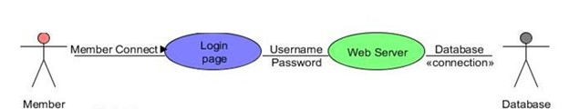The administrator also uses same things provided to the user. The pages that only the administrator can use only are also made by using HTML and CSS and the database is shared by both administrator and the user which is created using MY SQL. The connection between the front end and backend is made using FLASK. Only the system administrator is capable of entering the system to alter and add new data. For entering inside the administrator has to click

on the login button and give his credentials that is his username and password. After entering valid credentials, the administrator can enter and perform, required actions. For the system administrator to enter, he or she must give proper credentials for validation. The system first checks it with the stored valid login credentials, if they match the administrator is logged in, else it will take to an error page that shows that the login credentials are invalid.

The user can retry again by re-entering the credentials.

**Tools used for accomplishing this are:**

**MySQL**

It is used for creating the data base that contains all the data that is required for this work.

It also provides various other functionalities like triggers, procedures, views, indexes and joins.

**HTML**

It is used in the project for making the basic structure of the frontend side of the webpage.

It provides the basic structure such as the layout, how the data fetched will be represented etc.

**CSS**

It is used for styling the front-end part, for making it more attractive and nicer.

It provides all sort of styling options, which makes it very convenient for the users.

**FLASK**

It is used for making the connection between the front-end side and backend side of the web side.

It is basically used for making the server-side part. All the buttons on the front-end menu bar will work only when they connected to the database with the help of this server.

**Chapter 5**

**System Testing**

The website was tested with a set or random generated data. The data included a multiple testcases to ensure that all things run as expected. The website is hosted on local servers. Test cases of leaving the website without logging out or trying to extract user data without a proper login id and / or password is also tested.

The password entered mechanism is also tested to ensure that the new Password is compliant with the standard of:

1: a minimum of one letter

2: a minimum length of 8

|  |  |  |  |  |
| --- | --- | --- | --- | --- |
| S. No. | Description | Username | Password | Status |
| 1. | Incorrect Username and Password | Administrator | Pass | Fail |
| 2. | Incorrect Username and Correct Password | Administrator | password | Fail |
| 3. | Correct Username and Incorrect Password | admin | Pass | Fail |
| 4. | Correct Username and Password | admin | password | Pass |

**Chapter 6**

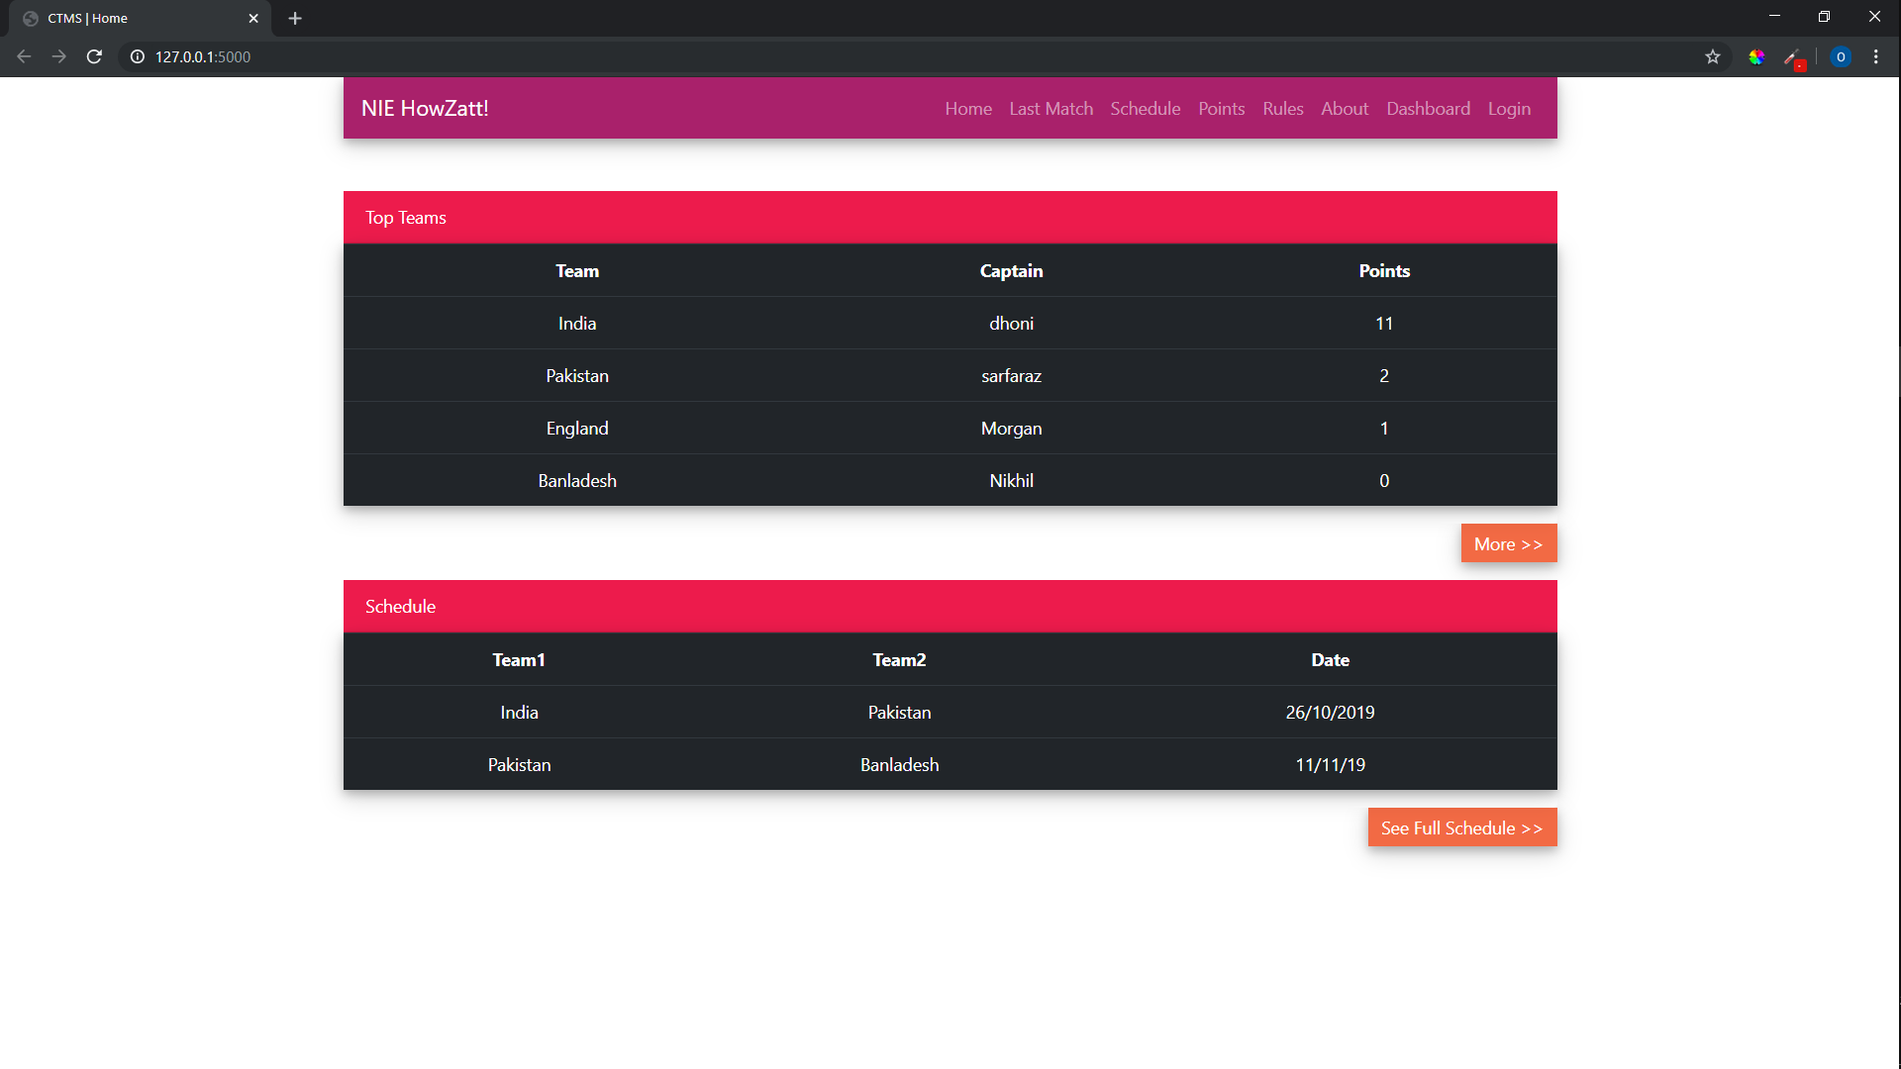**Results**

Fig 6.1 – Home Page

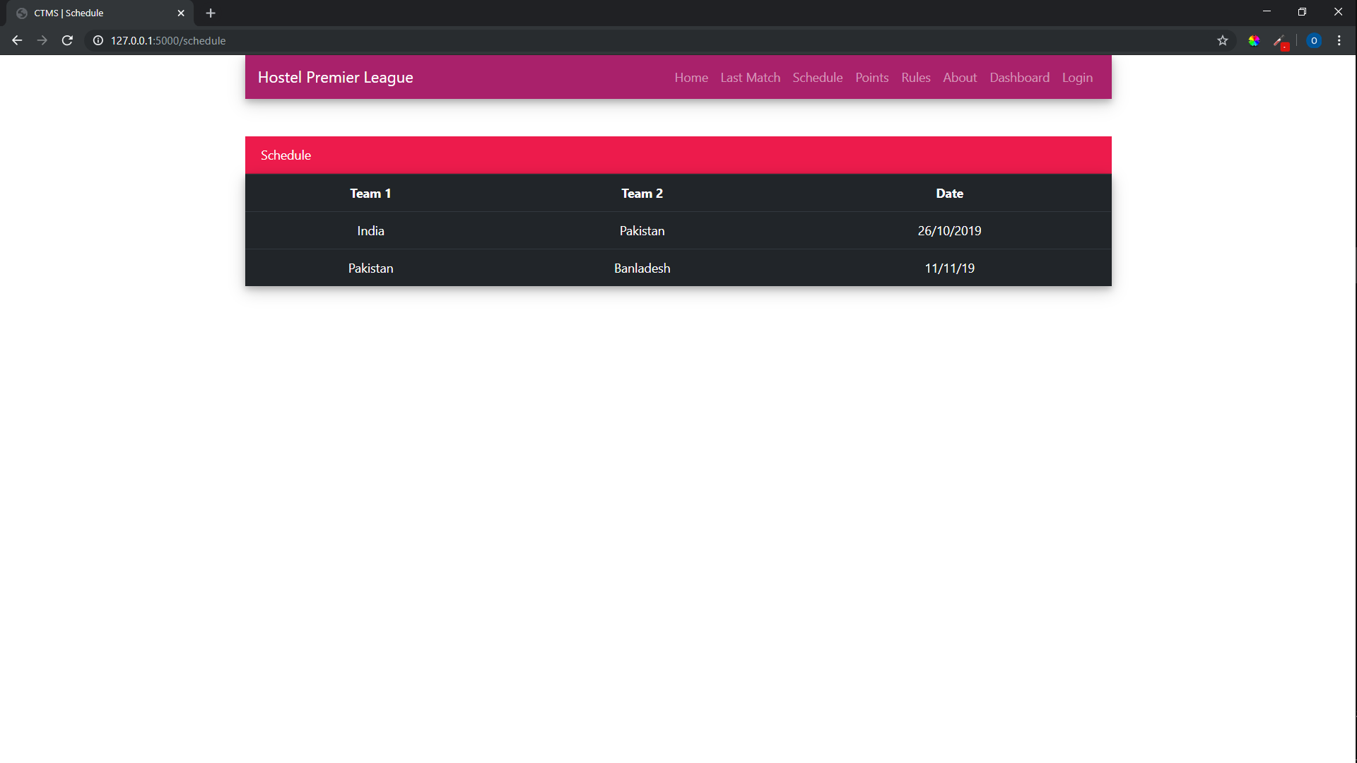

Fig 6.2 – Schedule Table

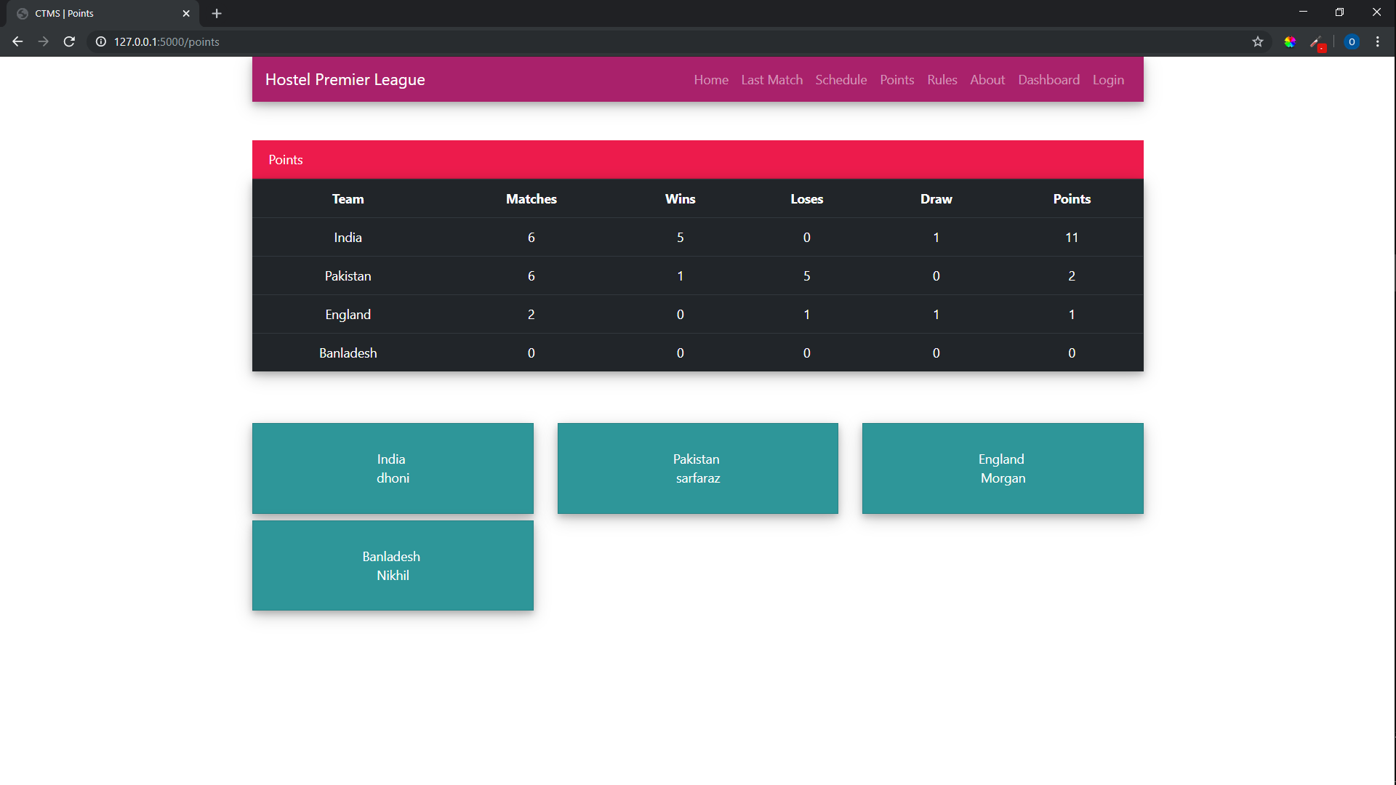Fig 6.3 – Points Table

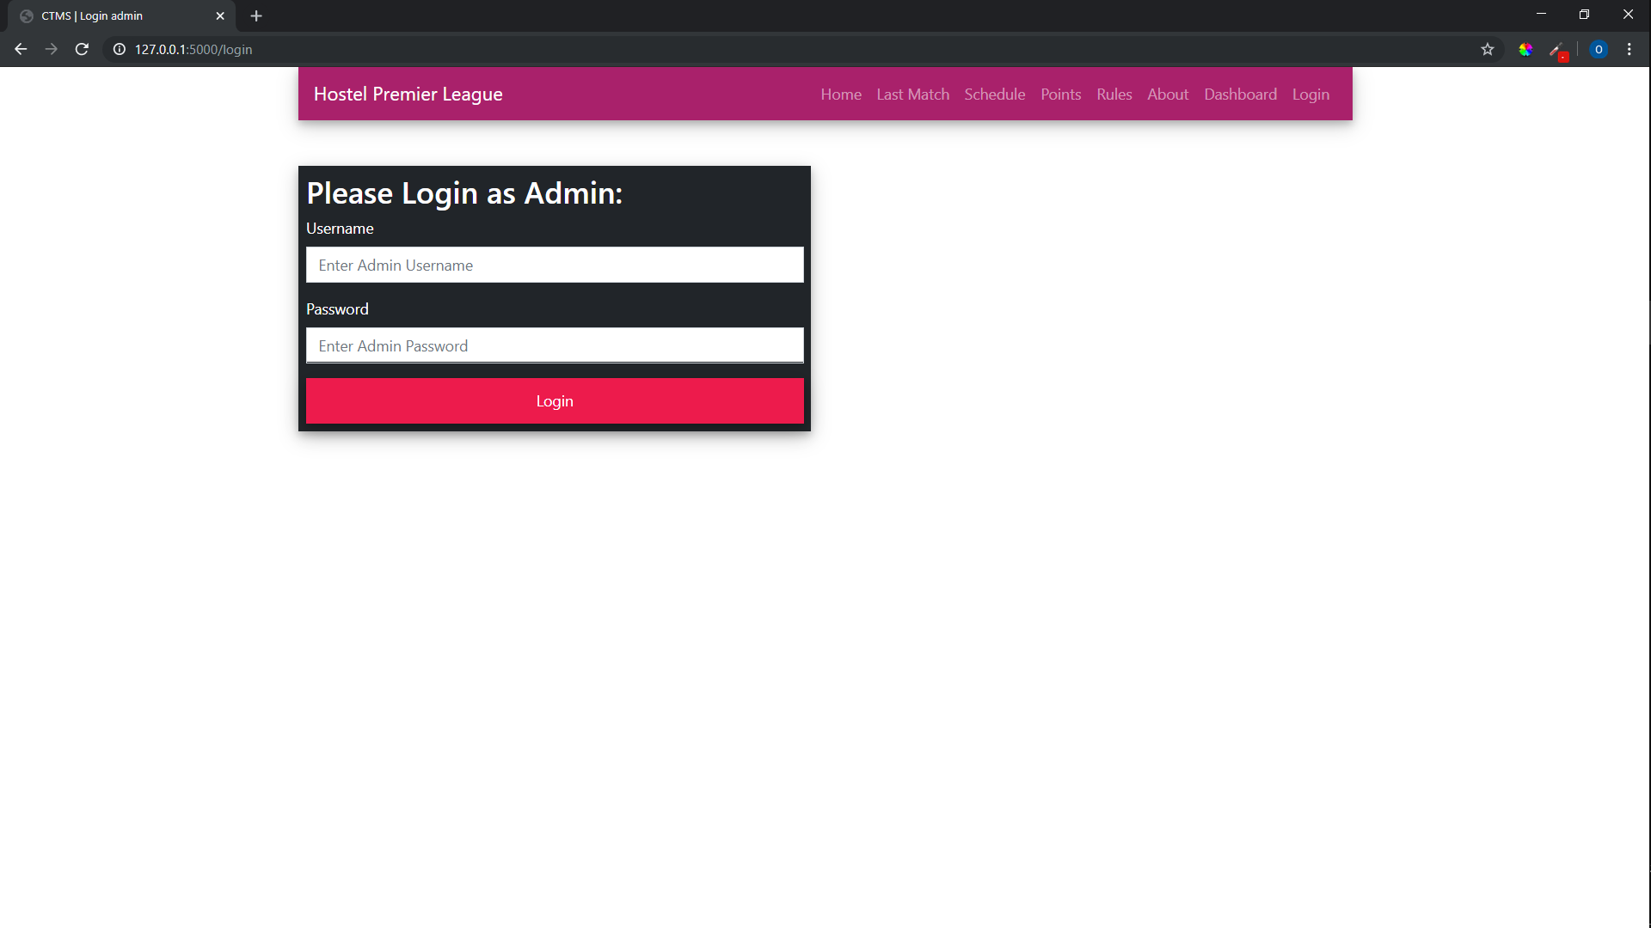

Fig 6.4 – Login Page

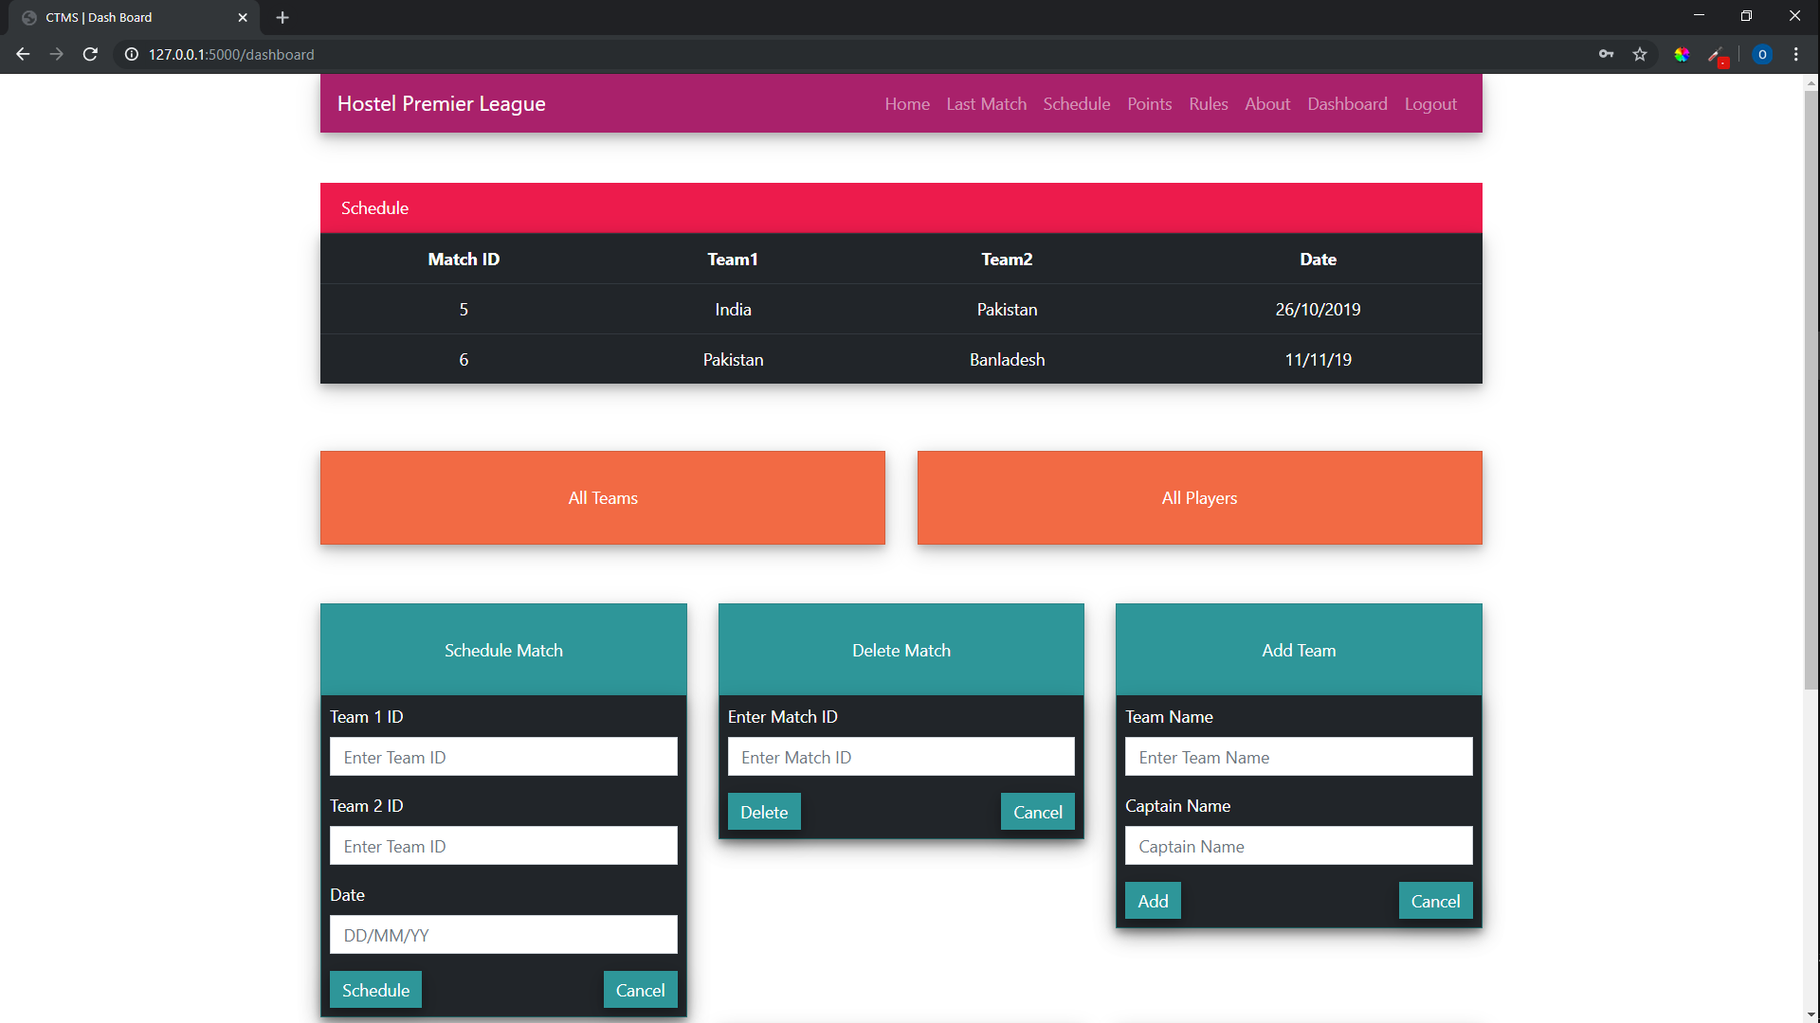 Fig 6.5 – Admin Dashboard 1

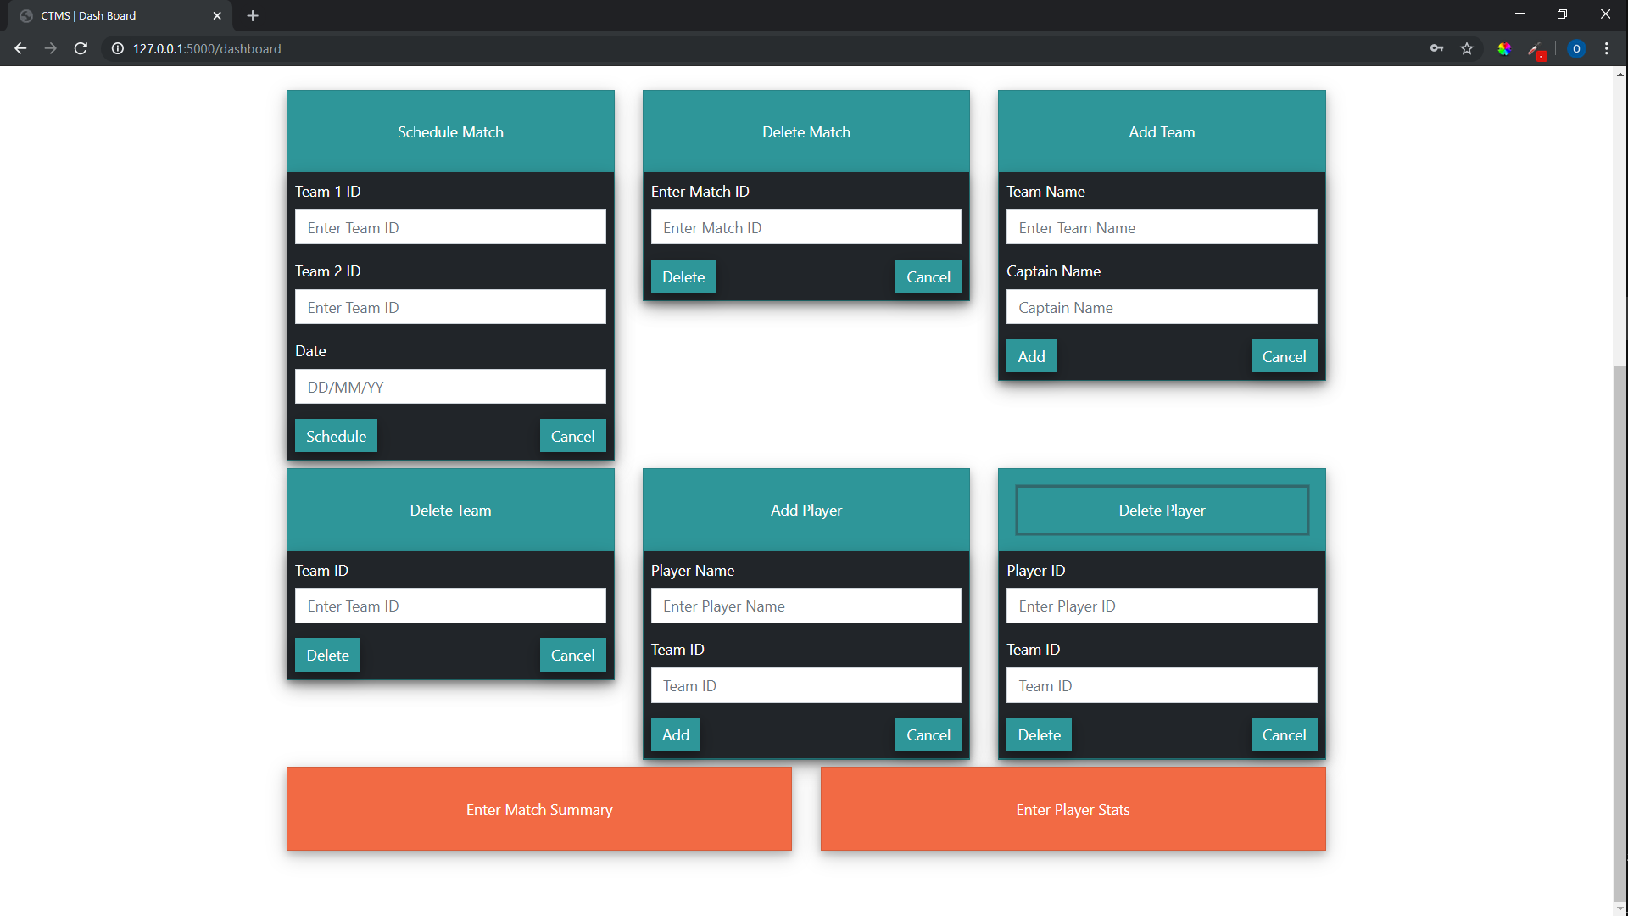

Fig 6.6 – Admin Dashboard 2

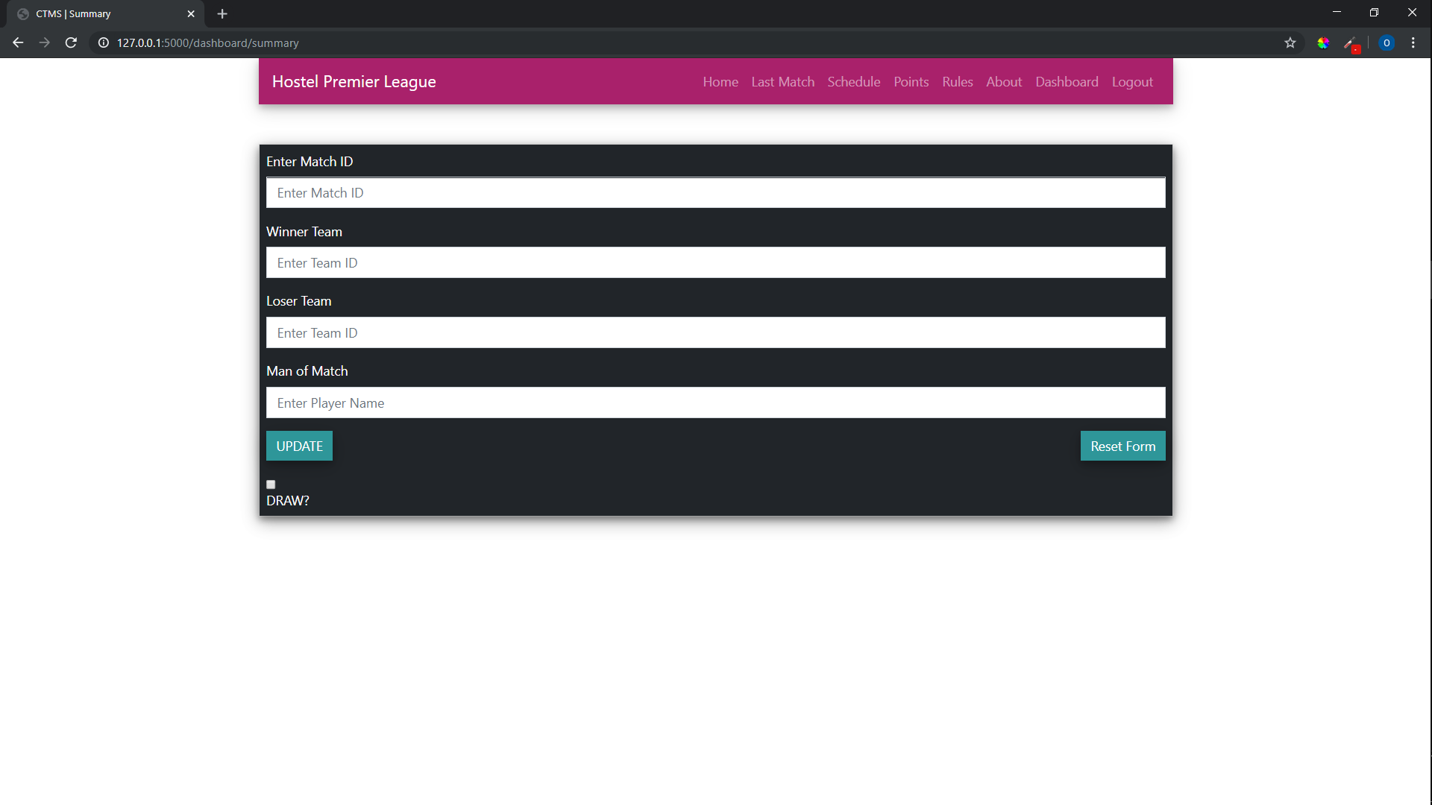

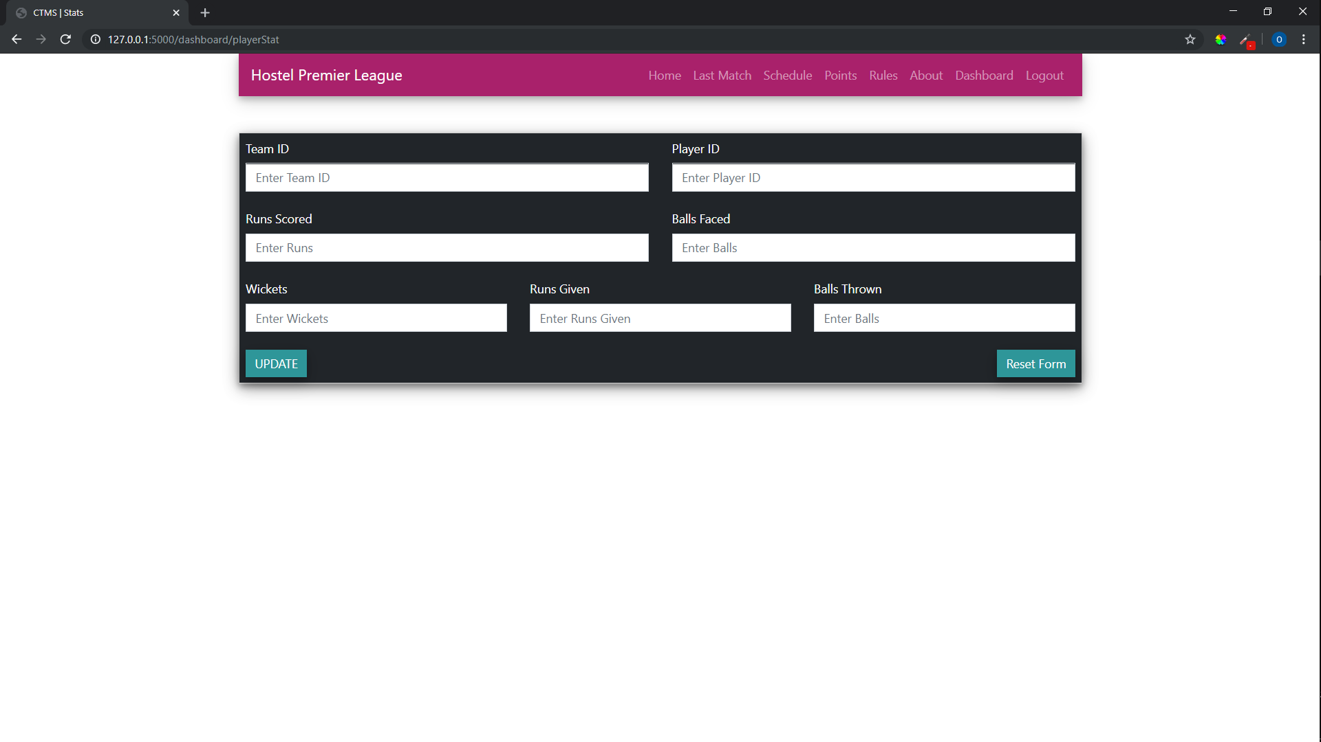Fig 6.7 – Match Summary Insert

Fig 6.8 – Player Statistics Update

All the above screenshots are of the website in working mode. each one of the show different functionalities of the website.

Each one belongs to one function part like the first one is the start page, after that one is the main home page.

The home page contains all the facilities provided and to use them the user just has to click on them.

There is a login for the system administrator where he can enter his or her credentials for entering into the system and updating and adding new values, if he enters wrong details it will take him to a error page ,else if the details are correct a form appears where the new details of a player can be entered.

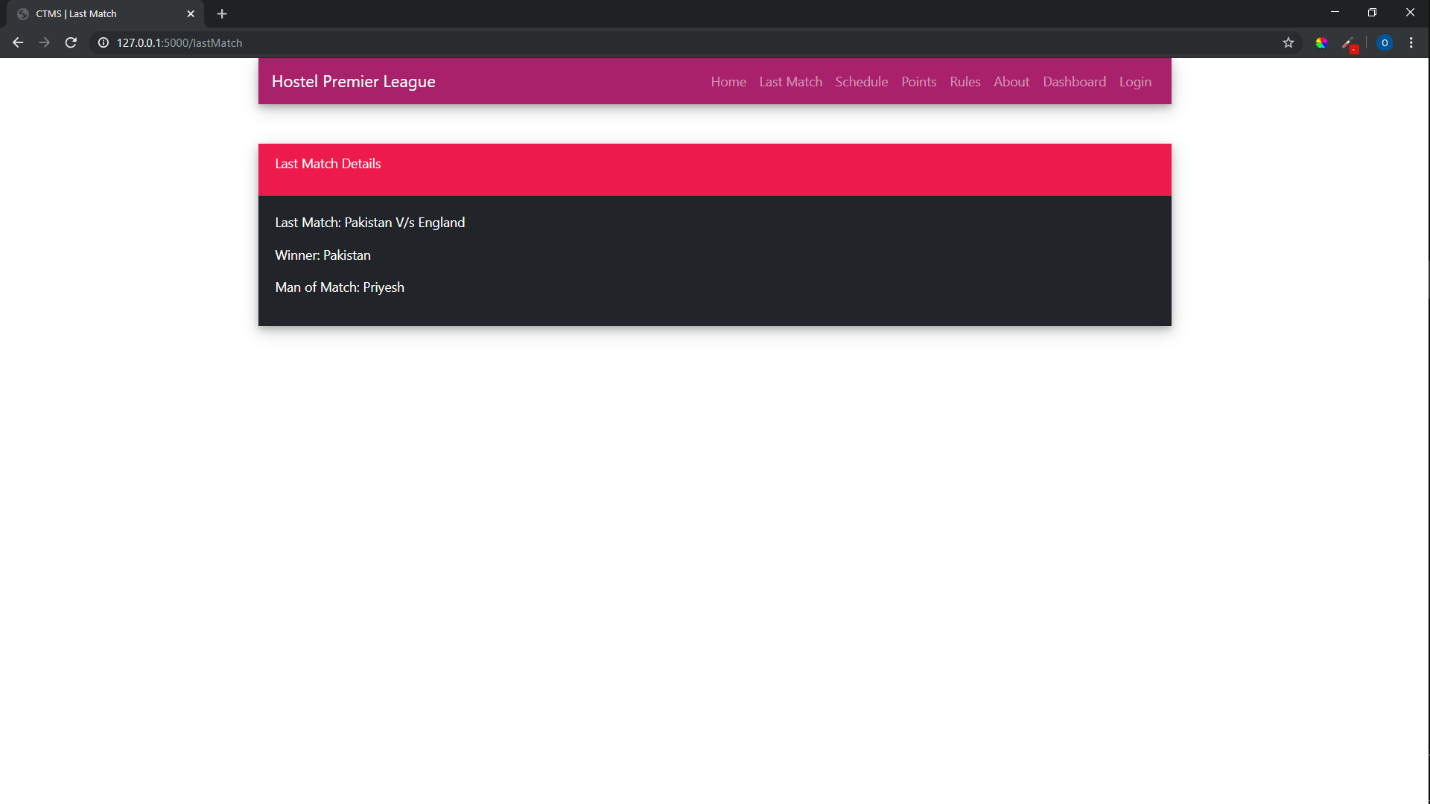MORE SCREENSHOTS:

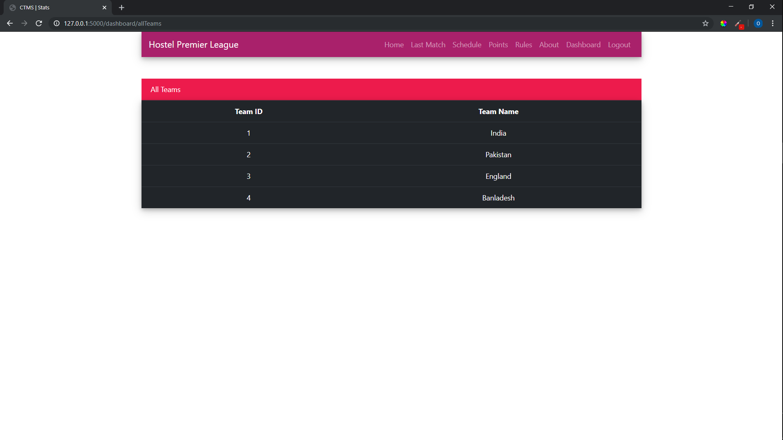Fig 6.9 – Last Match Details

Fig 6.10 – Teams Table (Reference for Admin)

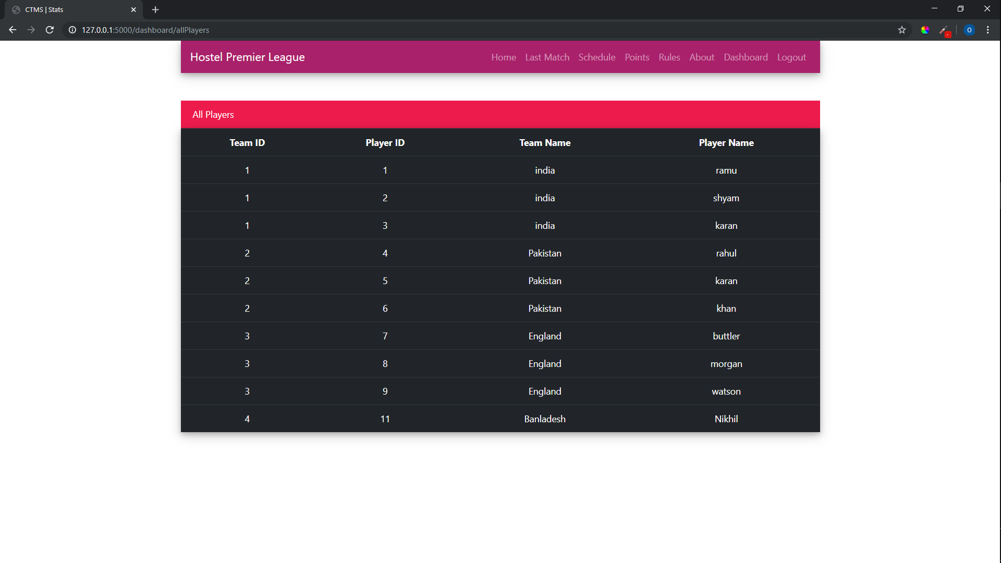

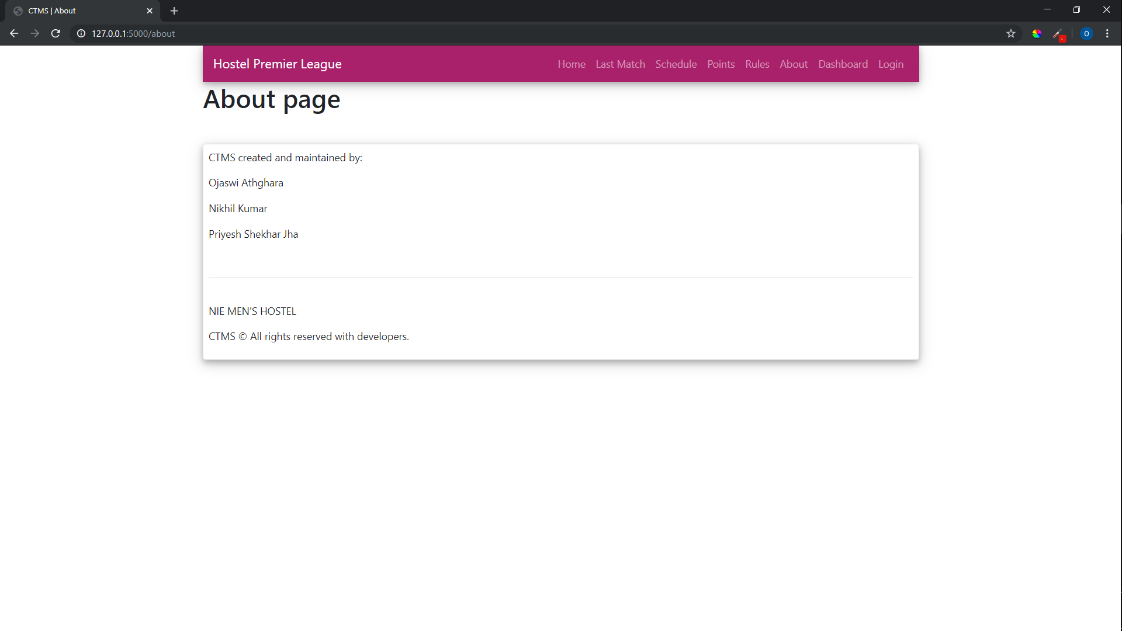Fig 6.11 – Players Table (Reference for Admin)

Fig 6.12 – About Page and Credits

**Chapter 7**

**Conclusion and Future Enhancements**

**CONCLUSION:**

After the successful completion and implementation of this website, this will the existing pen paper system which can be tampered with and is very difficult to manage.

Students and other people can see a player and team stats from the comfort of their rooms. The online system makes sure that only correct information and statistics are shown.

The site was designed keeping in mind all the age groups such that none of them will find any difficulty in using it and operating the site.

**FUTURE ENHANCEMENT:**

There is a lot of scope for this project in future. This app is scalable to all types of sports with some minor changes. This app can be implemented on all domestic and international tournaments. The technologies used are open source and can be run on any platform. The technologies used to design the app are scalable and hence the app can be scaled for very large applications.

The current plan is to extend this system for other tournaments in NIE such as Badminton, Basketball, Football, etc. The system can also be extended to manage the Inter-Branch Tournament in NIE or other colleges.

**Chapter 8**

**References**

* 1. **[BOOK]** The Database book: Principles and Practice using MySQL, Narain Gehani,
  2. Universities press(India) private Limited 2008
  3. **[BOOK]** Fundamentals of Database System, Elmasri and Navathe, Addison-Wesley,
  4. 5th edition,2007
  5. **[WEBSITE]** www.w3school.com for HTML, CSS, JavaScript tutorials.
  6. 4​. **[WEBSITE]** www.materialize.com for materialize package
  7. **[WEBSITE]** www.youtube.com for flask tutorials
  8. **[WEBSITE]** http://stackoverflow.com/ to solve common problems